**A computer with these software installed.**

Requires IT if using an ISU computer. If not using ISU computer all can be downloaded on a personal computer. Make sure IT installs most recent versions. Alternatively, ask IT to place most current versions of R and RStudio in ‘Software Center’ so you can download it yourself

* **R**:
  + <https://cran.r-project.org/mirrors.html>
    - Scroll down to ‘USA’ and download one of these. Doesn’t matter which one



* + - (<https://www.r-project.org/> main R download page placed here only for reference)
* **RStudio**: <https://www.rstudio.com/products/rstudio/#Desktop>
* **Git**: <https://git-scm.com/downloads>

**An account on** [**github.com**](http://github.com) **(ideally use your iastate email)**

* *not necessary: request an education discount (requires iastate email): <https://education.github.com/>
* Once account is created share (via email) the email, username, and avatar with Seth/Dr. Jarad Niemi (in the statistics department) so that you can be connected to the repository
  + Dr. Niemi will add you to github repository. You should receive an email from github with an invite to join the ISUmonarch repository. Please click on the link in the email and then accept the invitation.

**Then in RStudio,**

* setup git and ssh keys on your computer: <https://www.r-bloggers.com/rstudio-pushing-to-github-with-ssh-authentication/>
  + (when creating your ssh keys, do not put in a passphrase)
  + If you get an error at end that says something like “the authenticity of host ‘github…’ can be established…”
  + See this website <https://help.github.com/articles/testing-your-ssh-connection/>
* This is what Git shell will look like throughout the process

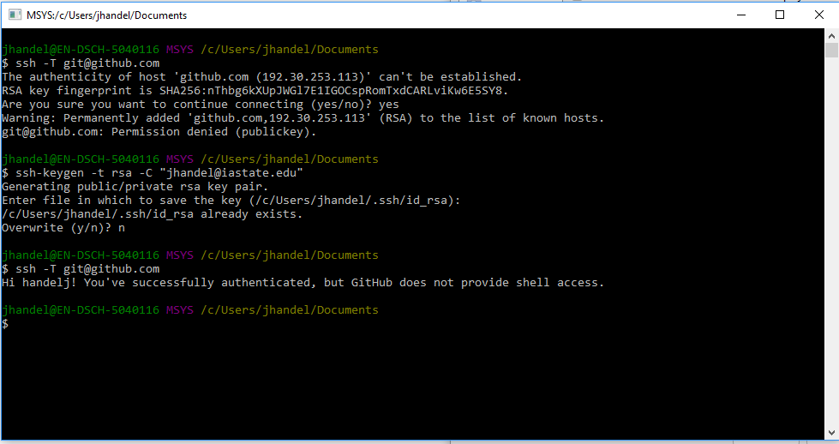

* *Another option which may help with setting up ssh keys <https://help.github.com/articles/connecting-to-github-with-ssh/>

**Cloning Repository**

Option #1 (works)

In R studio

* Click on ‘project’ in the top right
* Click on ‘new project’
* Click ‘version control’
* Click ‘git’ option
* Copy and paste repository URL and project directory name. To copy these so that you can paste…
  + Navigate to the repository in Github
  + Click the ‘clone or download’ button.
  + Copy the URL or push the icon on the right (should do the same thing)
* It should download stuff for a long time and downloading box title should say ‘clone repository’

Option #2 (should work but not sure)

In Github

* Navigate to the repository in Github
* Click the ‘clone or download’ button.
* Click ‘download zip’

In computer folder system

* Within the computer folder system, select the zipped file and extract it to a new folder in ‘documents’. Name the new file ‘Git’

In R studio

* Click on ‘project’ in the top right
* Click on ‘New project’
* Click on ‘Existing project’